GIT AND GITHUB Task1(class9&10)

1. Watch the video and write notes.

done

2. Create a GitHub account.

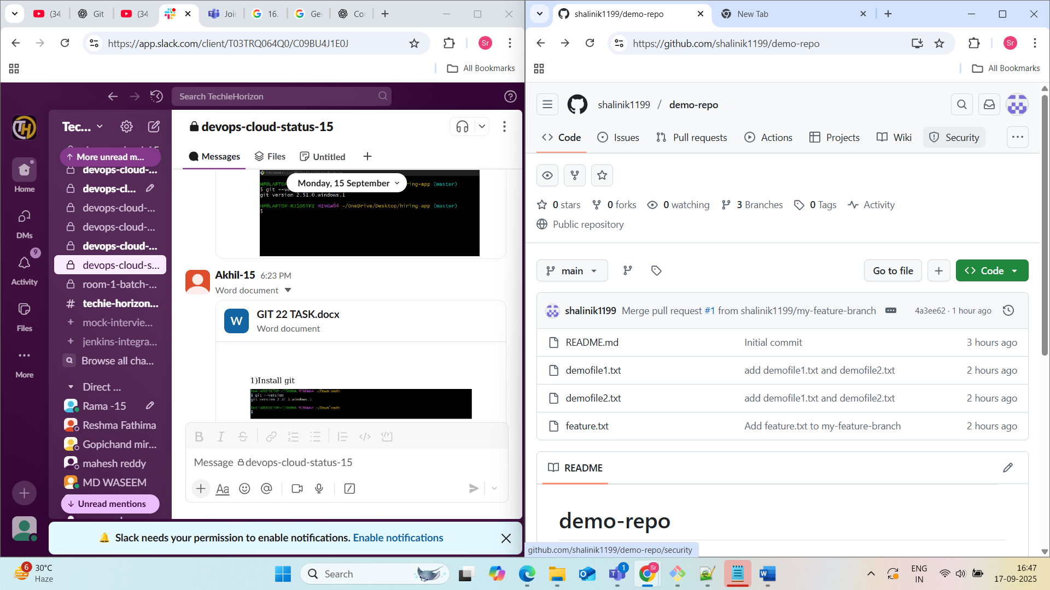

**Navigate to https://github.com/.**

1. Click Sign up.
2. Alternatively, click on Continue with Google to sign up using social login.
3. Follow the prompts to create your personal account.

3. Set up MFA (Multi-Factor Authentication) for the GitHub account using a mobile app.

To set up Multi-Factor Authentication (MFA) for your GitHub account using a mobile app, follow these steps:

* **Download a TOTP (Time-based One-Time Password) app:**

Choose a reliable TOTP authenticator app for your mobile device (e.g., Google Authenticator, Microsoft Authenticator, Authy, or the GitHub Mobile app itself).

* **Navigate to GitHub settings:**
  + Log in to your GitHub account on a web browser.
  + Click your profile picture in the upper-right corner of any GitHub page.
  + Select Settings.
* **Access Password and authentication settings:**
  + In the "Access" section of the sidebar, click Password and authentication.
* **Enable Two-factor authentication:**
  + In the "Two-factor authentication" section, click Enable two-factor authentication.
* **Set up using an app:**
  + GitHub will present options for setting up 2FA. Choose the option to Set up using an app or similar wording, which will typically involve scanning a QR code.
* **Scan the QR code:**
  + Open your chosen TOTP authenticator app on your mobile device.
  + Initiate the process to add a new account (usually by tapping a "+" icon).
  + Select the option to scan a QR code.
  + Point your phone's camera at the QR code displayed on the GitHub website. The app will automatically detect and add your GitHub account.
* **Verify the code:**
  + The authenticator app will now display a six-digit code that changes every few seconds.
  + Enter this code into the corresponding field on the GitHub website under "Verify the code from the app."
* **Save recovery codes:**
  + GitHub will provide a list of recovery codes. Download these codes and store them in a secure, offline location. These codes are crucial for accessing your account if you lose your phone or access to your authenticator app.
  + Confirm that you have saved the recovery codes.
* **Complete setup:**
  + Click the button to finalize the 2FA setup.

Your GitHub account is now secured with MFA using your mobile authenticator app. You will be prompted to enter a code from the app each time you log in to GitHub.

4. Execute all commands shown in the video

